**Analysis of all the visualizations with respect to how it is helping you find the Key Performance Indicators and the causes of various problems identified.**

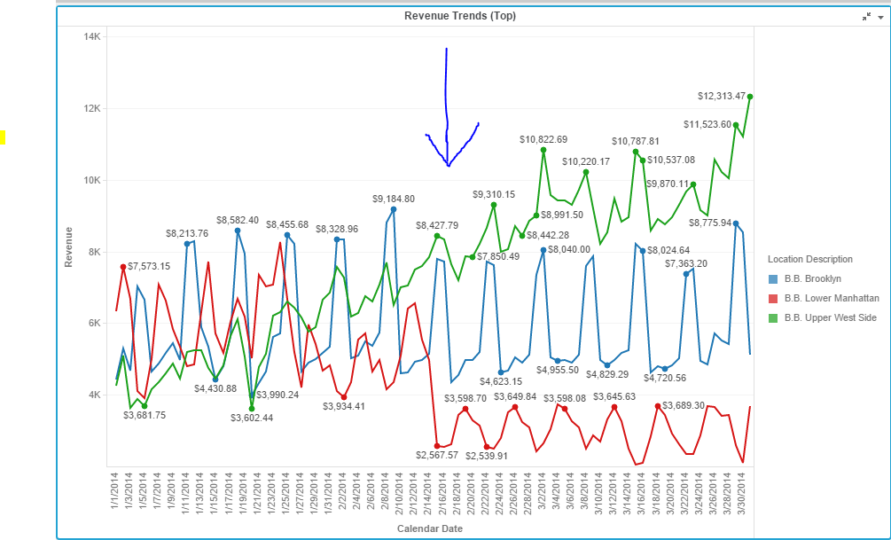

By plotting the above line graph for three locations, we can see that the revenue for all three locations is almost same until middle of February where they all start moving in different directions. This graph helps us observe the revenue trend for these locations.

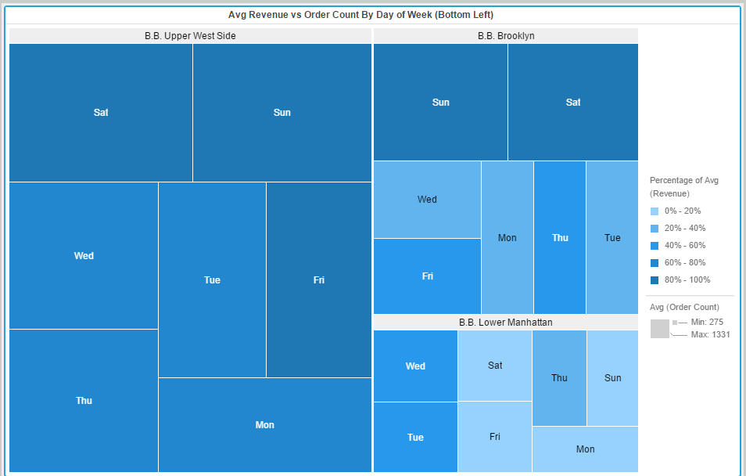

By Plotting the above HeatMap,We can observe the Avg(Order Count) and Avg(Revenue) at specific day and location, we can see that In Lower Manhattan, size or order count is least and has most light blue color (Least revenue) . It was red line in line chart before.This graph gives insight about order count at different locations and avg revenue which is same conclusion as before in line chart.

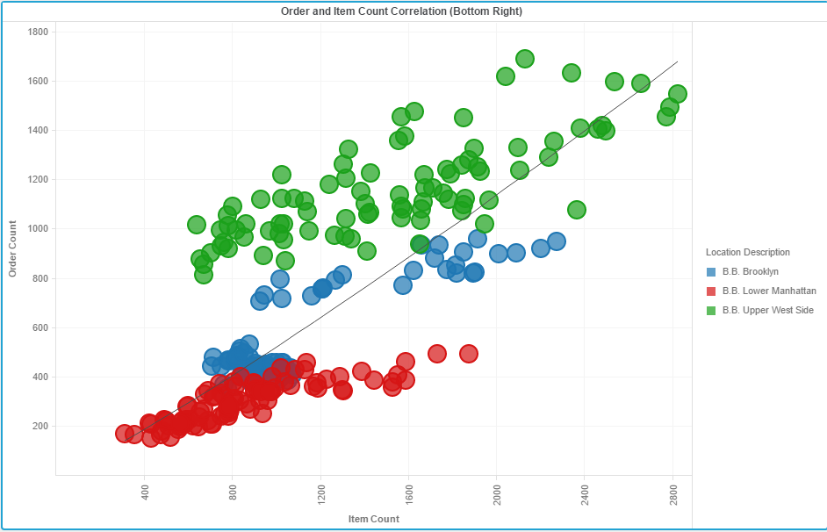

The Third visualization (Bubble Chart), shows the correlation between the Order and item count. We can see a trend line along 45 degrees, Green color dots of Upper West Side are mostly above the Trend Line , that means almost always order count is above line in Upper West Side. Whereas Red color Lower Manhattan values are below the line always.

The above three graph visualizations make it clear that:

1. Restaurant at B.B.Upper West Side is performing the best.
2. Restaurant at B.B.Lower Manhattan is performing the worst.

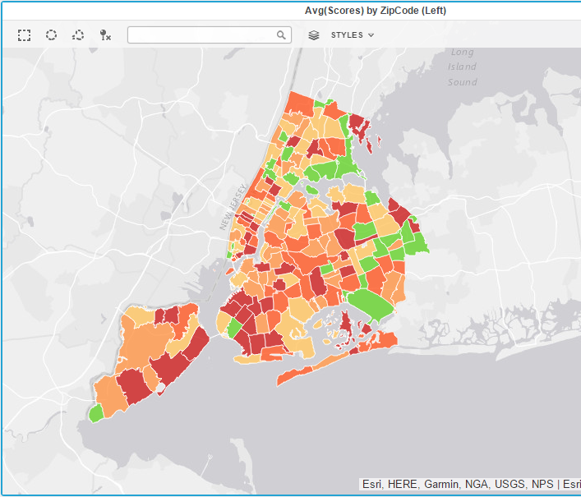

Now we focus on other dataset NYC Health Inspections,we plot it in map by zip codes to have an overview of the regions.Green Color have lowest score and Red have the higher scores. We can see more number of red patches than green ones.

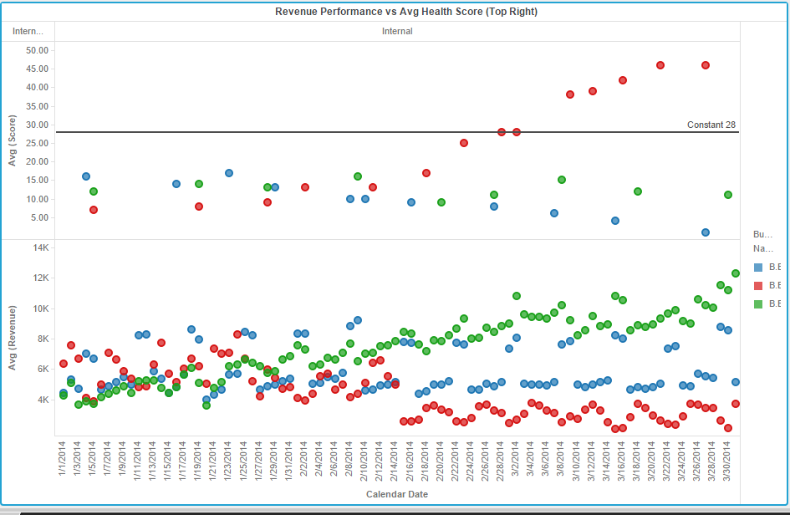

Next Visualization , we now see that health score affects the revenue at three locations.Avg(Score) is most for Red(Lower Manhattan) is correspondingly it has lowest revenue.Inpection above Reference Line of 28, receives C Grade and we see red dots are above that line.So higher scores is affecting the revenue.Thus, health scores should be looked into so that revenue performance can be improved.

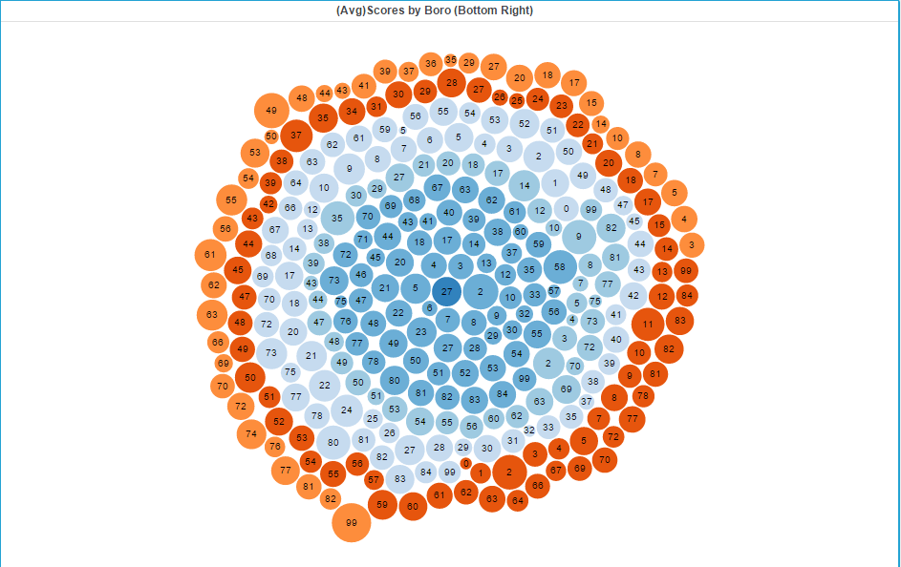

Above D3 Graph helps us to find whether there are any cuisines that fare good across multiple boro’s.

**What more could you have done other than what is included in the exercise to achieve better analysis of both the datasets?**

We can plot a bar graph, trying to find out the Avg(Revenue) on different week days.

We should see the Red bars which are so low on Sat,Sun.(Lower Manhattan)